PHASE 2 SUBMISSION

Predicting House Price using Machine Learning

Withtheintroductionofthepowerofmachinelearning inpredicting house pricesusing Pythonhasrevolutionized thereal estate industry. Inthisarticle,we explore the dynamic world ofhouse price prediction using cutting-edge machine-learning techniques.Byharnessing the vastpotentialofdataanalysis,featureengineering,andmodel traininginPython,weaim toprovideacomprehensive guidethat equipsreaderswiththe toolstomake informed decisionsinthe ever-changinghousing market.

Linearregressionforhousepriceprediction~~:~~

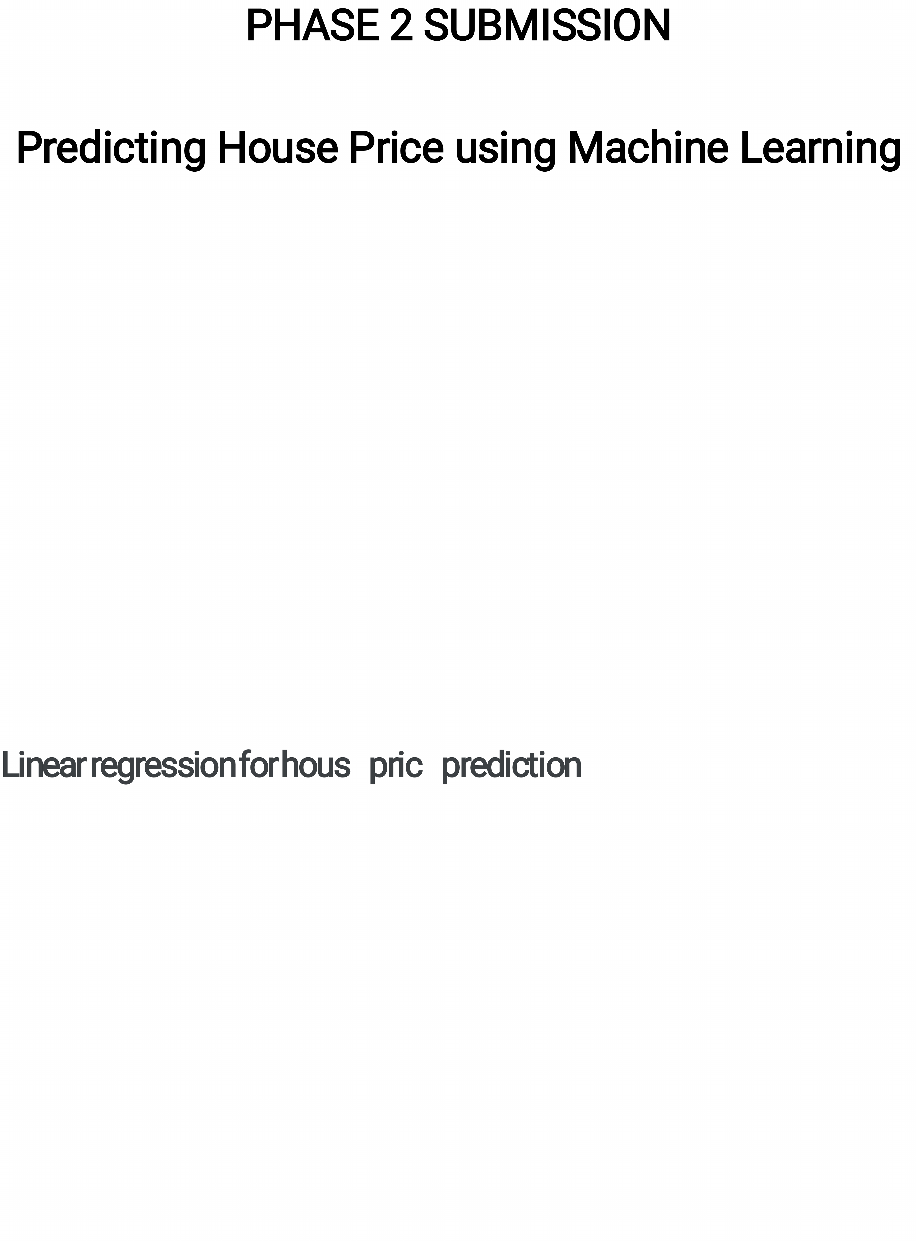Linearregressionisamainlyusedtechnique forthe predictionof house pricesdue toitssimplicityandinterpretability.Itassumesa linearrelationshipbetweentheindependentvariables(suchashow manybedrooms,numberofbathrooms,and squarefootage)and the dependentvariable(houseprice).Byfittinga linearregression model tohistoricaldata,we canestimatethecoefficientsthatrepresentthe relationship between the targetvariable and thefeatures. This enablesustomake predictionsonnewdatabymultiplying the feature valueswiththeirrespective coefficientsand summing themup.

Linearregressionprovidesinsightsintotheimpact ofeachfeature on thehouse price,enabling ustounderstand thesignificance of differentfactorsand make informed decisionsinthereal estate market.

Housepricepredictionusingmachinelearning:

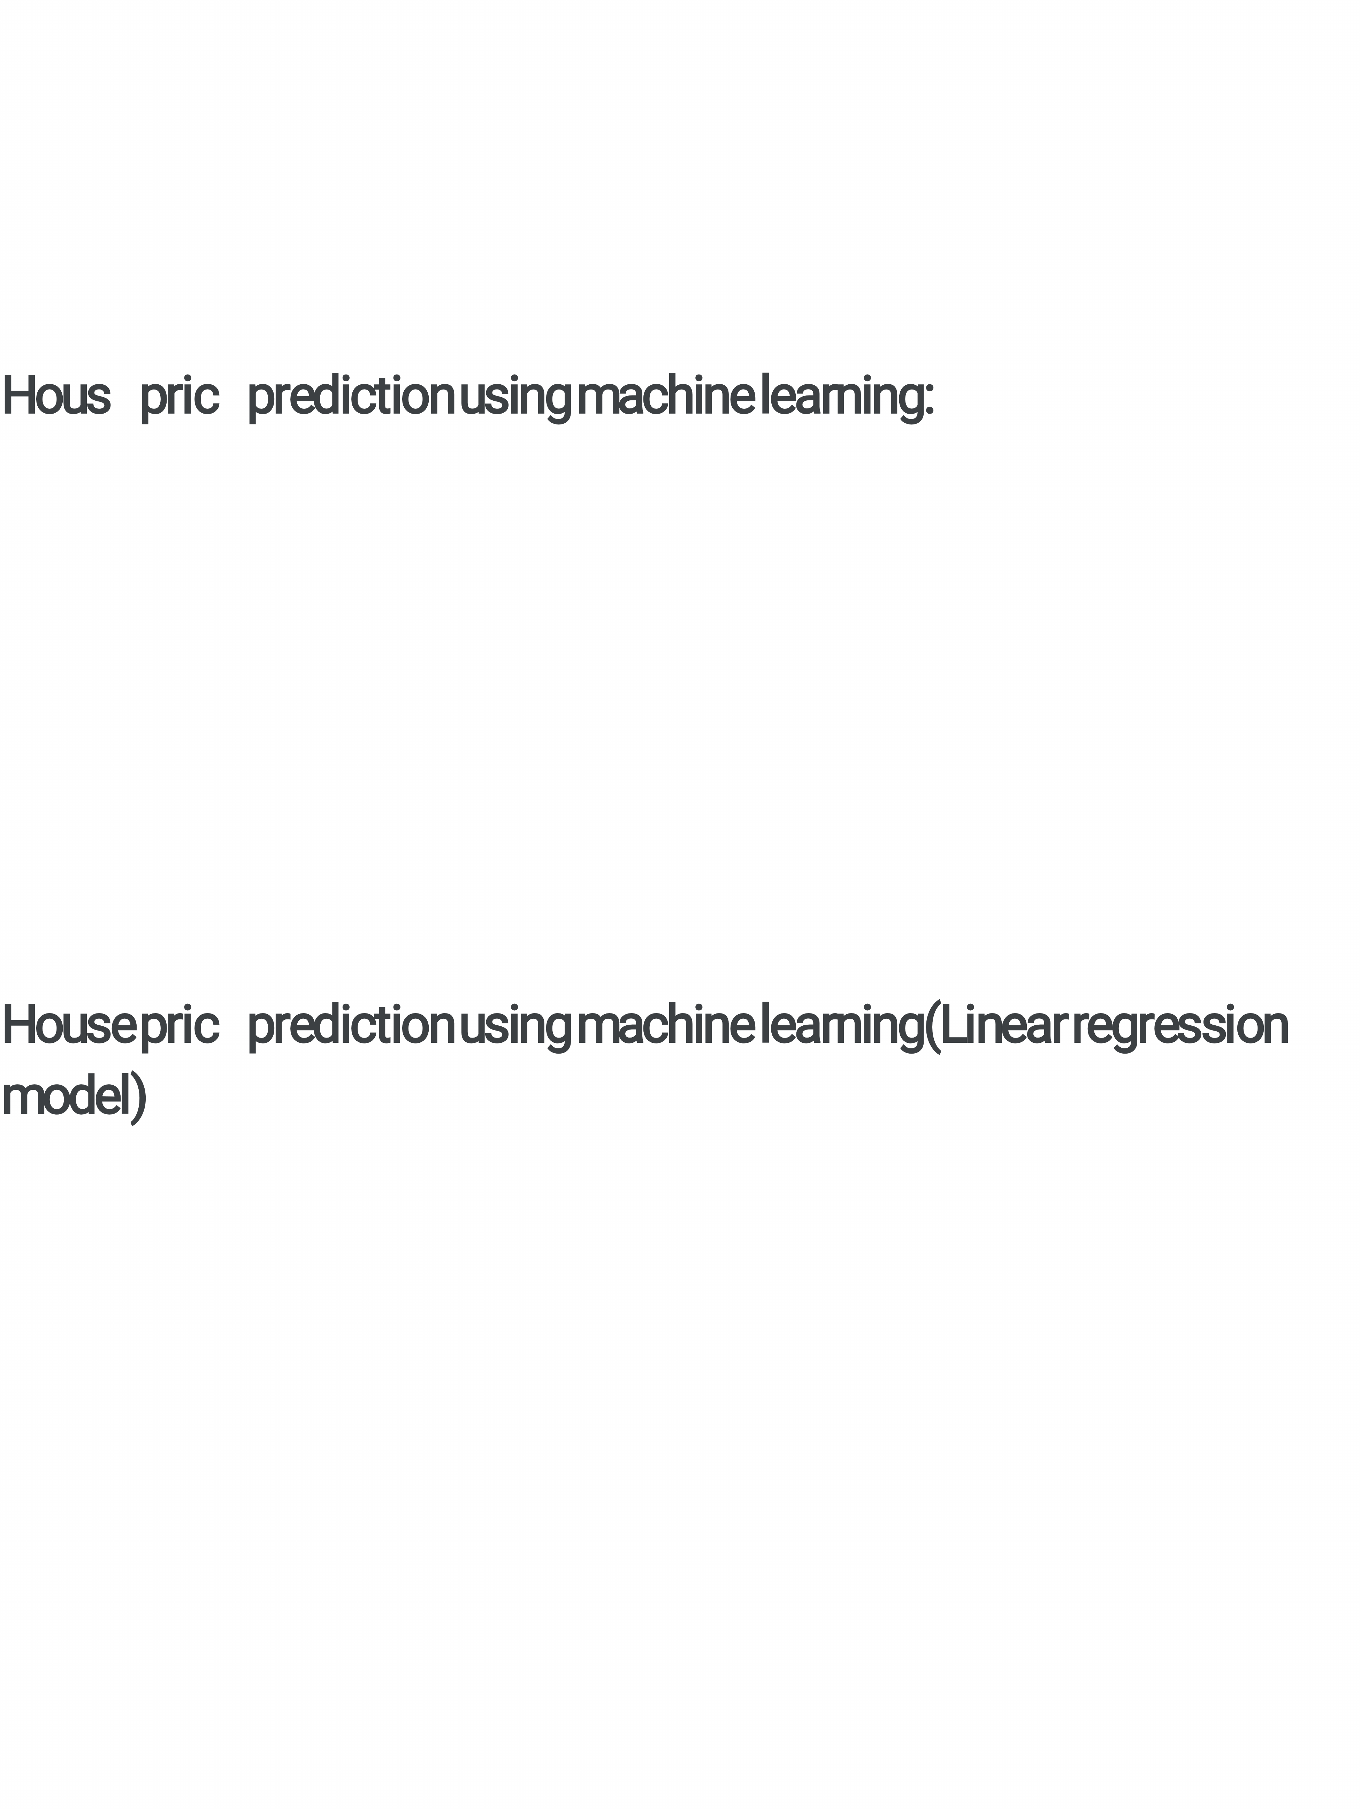Machinelearning involvestraining acomputer torecognize patterns andmake predictionsbased ondata.In the case ofhouse price prediction,we canuse historicaldataonvariousfeaturesofahouse, suchasitslocation,size,and amenities,totrainamachine-learning model.Oncethemodel istrained,itcananalyze newdataonagiven house andmake apredictionofitsmarketvalue.

Housepricepredictionusingmachinelearning(Linearregression model)

Follow thestepsgivenbelowtoperformthepredictionofhouse pricesusing machinelearning −

We haveused Kaggle kc_house_datadataset.

Importtherequiredlibrariesand modules,including pandasfordata manipulation,scikit-learnformachinelearning algorithms,and LinearRegressionforthelinearregressionmodel.

Loadingtherequired datasetwithpd.read_csvand selectthefeatures wewanttouseforprediction(e.g.,bedrooms,bathrooms,sqft_living, sqft_lot,floors,and zip code),aswellasthetargetvariable (price).

Splitthe dataintoa training setand atestsetusing the train_test_split function,with 80%ofthe dataused fortrainingand 20%fortesting.

Createaninstance ofthelinearregressionmodel using

LinearRegression().We thenperformthemodel trainingbycalling the functionfit()withthetraining data.

Oncethemodel istrained,wemake predictionsforthetestdataset using predictandstoretheresultsiny_pred.

Toevaluate the performance ofthemodel,we calculate the R^2 score using thescoreforthetestset.

Demonstratehowtopredictthepriceofanewhousebycreating a newdataframe new_housewiththe featuresofthe house.We pass thisdataframetothemodel'spredictionfunctiontoobtainthe predicted price.



Example

fromsklearn.model_selectionimport train_test_split fromsklearn.linear_modelimportLinearRegression importpandasaspdd

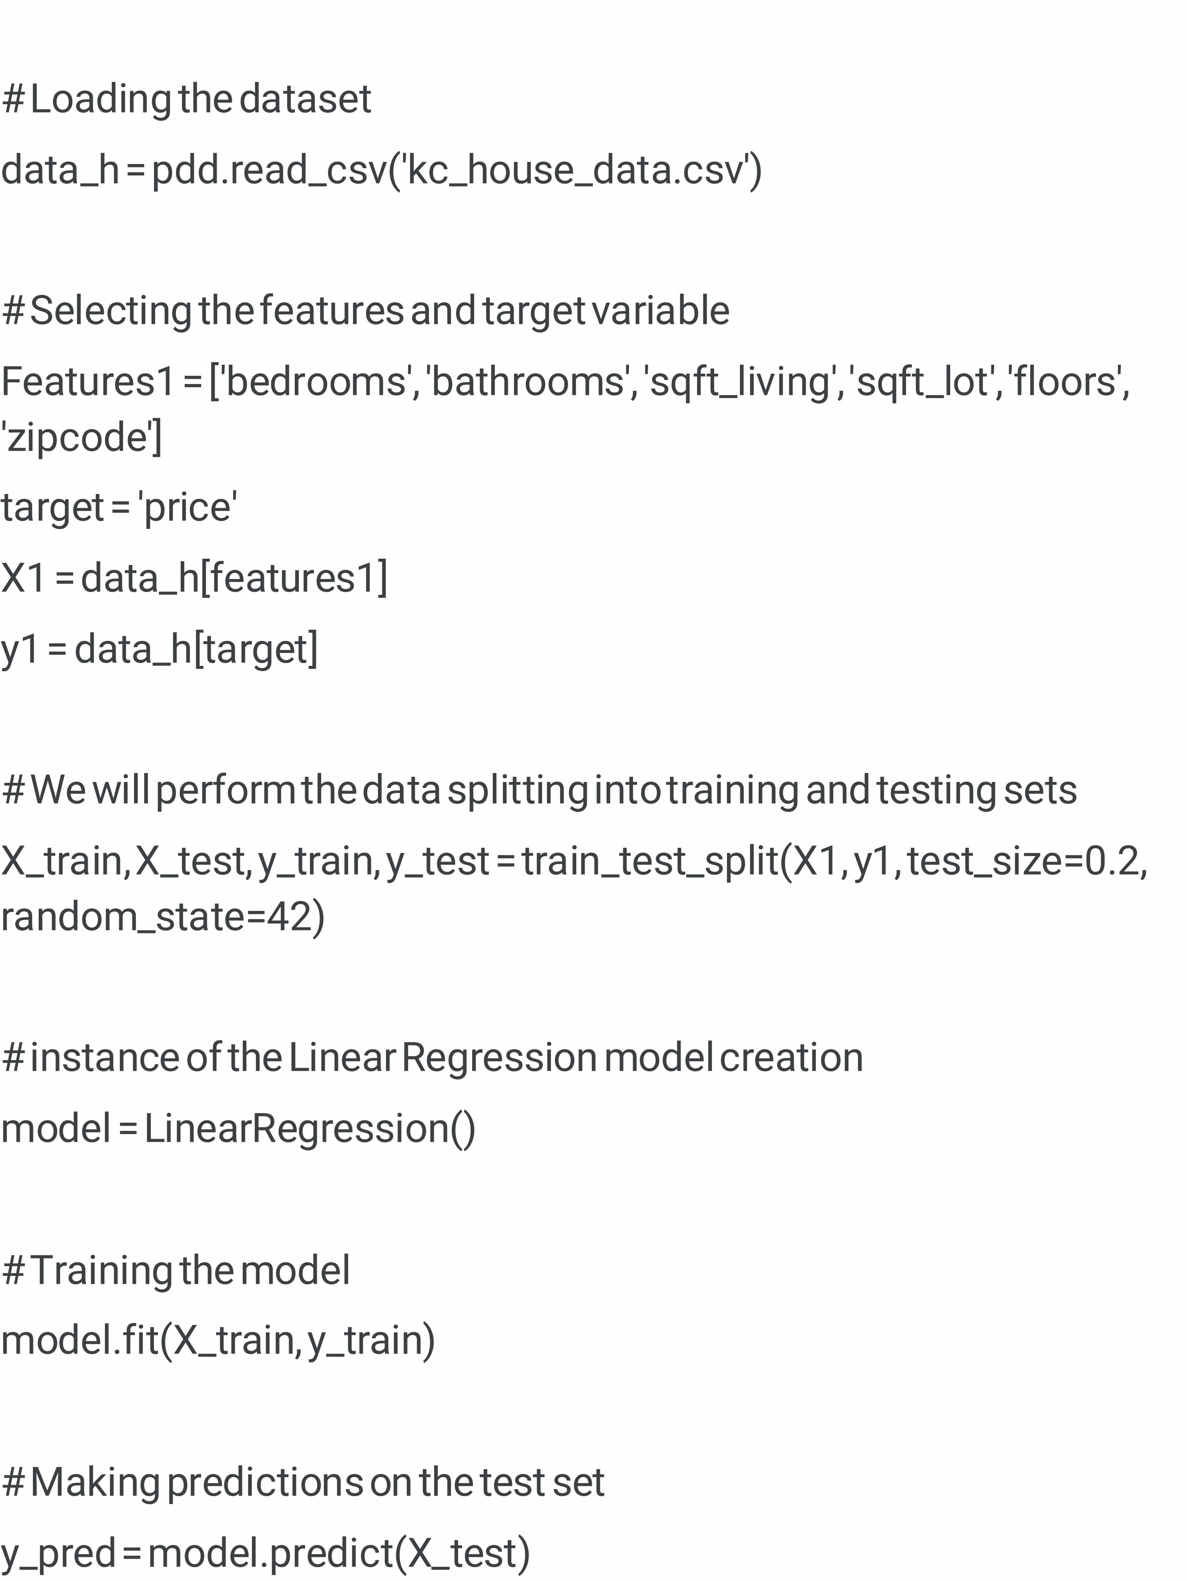

#Evaluating the model score=model.score(X_test,y_test) print("Model R^2 Score:",score) #Predicting the price ofanewhouse new_house =pdd.DataFrame({'bedrooms':[2],'bathrooms':[2.5],



'sqft_living':[600],'sqft_lot':[600],'floors': [2],'zipcode': [98008]}) predicted_price =model.predict(new_house) print("Predicted Price:",predicted_price[0])

Output:

Model R^2Score: 0.5152176902631012

Predicted Price:121215.61449578404

Conclusion~~:~~

Inconclusion,usingmachine learninginPythonisapowerful tool for predicting house prices.Bygathering andcleaning data,visualizing patterns,and training and evaluating ourmodels,we canmake informed decisionsinthedynamicworldofreal estate.

Byleveraging advanced algorithmsand data analysis,wecanmake accuratepredictionsandinform decision-makingprocesses. This approachempowersbuyers,sellers,and investorstomakeinformed choicesina dynamicand competitivemarket,ultimatelymaximizing theiropportunitiesand outcomes.

